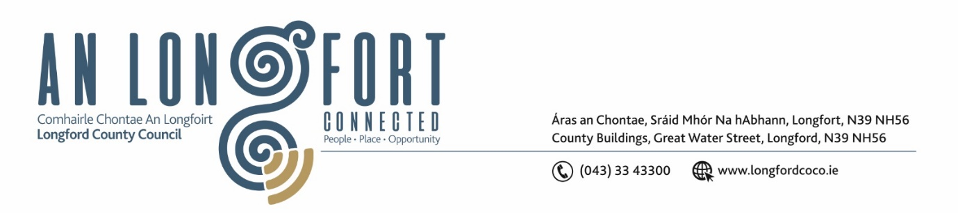

***Please note meeting will be held via Microsoft Teams.***

13 Eanáir 2022.

**Chuig: Gach Ball don Chomhairle.**

A Chomhairleoir,

Iarrtar ort bheith i láthair ag Cruinniú Míosuil Chomhairle Chontae Longfoirt a tionólfar via MS Teams are an **Chéadaoin 19 Eanáir 2022 ag** **3pm** chun gnó a dhéanamh d’réir an Chláir thíos.

You are requested to attend the Monthly Meeting of Longford County Council to be held **via Microsoft Teams** on **Wednesday, 19 January 2022 at 3pm** to transact business, as set out on the Agenda hereunder.

Mise le meas,

*Ann Marie Mc Keon*

**__________________**

**Ann Marie Mc Keon**

**Meetings Administrator.**

**C L Á R**

Prayer before meeting.

**1.** Confirmation of Minutes of Monthly Meeting of Longford County Council held on 8

December 2021 – copy enclosed.

**2.** Matters Arising.

**3.** Declaration of Interest by Members.

**4.** To note Management Report – enclosed.

**5.** To note adopted Minutes of Corporate Policy Group Meeting held on the

9 November 2021 – enclosed.

**6. Community, Corporate and Enterprise**

**(a)** Adoption of Service Delivery Plan 2022 – to follow.

**(b)** Annual Progress report on implementation of the Official Languages Act *–* enclosed.

**(c)** Political Donations - Local Elections (Disclosure of Donations

and Expenditure) Act 1999, as amended - Members of Local Authorities – enclosed.

**(d)** Political Donations - Local Elections (Disclosure of Donation and Expenditure) Act

1999, as amended - Third Parties – enclosed.

**(e)** Date of February 2022 County Council meeting.

**(f)** Notice of Motions, submitted by Councillors, as listed hereunder –

**Councillor Seamus Butler**

Due to a two-year backlog of Municipal and County Cathaoirleach’s awards yet to be presented, I request that a combined presentation be organised, as a matter of priority, as soon as COVID-19 restrictions permit.

**7. Strategic Infrastructure, Regeneration and Climate Change**

**(a)** To note Planning Applications received since last meeting of the Council.

**(b)** Presentation on the “Turnaround of Housing Stock”.

**(c)** Notices of Motions, submitted by Councillors, as listed hereunder –

**Councillor Uruemu Adejinmi**

“I call on Longford County Council to reach out to landlords of RAS properties, and

landlords in general if they wish to sell their properties to Longford County Council”.

**Councillor Paul Ross**

“I call on the Minister for the Environment to implement a policy where a database of registered Bin users in each county is available to each Local Authorities Litter Wardens to help identify those who do not dispose of their waste and rubbish in a proper manner. Illegal dumping is growing at a massive rate and is one of the greatest scourges of our county”.

**Councillor Paraic Brady**

“I call on Longford County Council to make the Civil Defence and trained first responders in the fire department available for emergency cardiac arrest cases as the ambulance service is not fit to cope at this time and waiting time could be halved or reduced significantly”.

**8. Correspondence**

1. Correspondence dated 13 December 2021 received from the Minister of Health -Re Notice of Motion from Councillor Pat O’Toole on Home Support Services – enclosed.
2. Correspondence dated 16 December 2021 received from the Minister of Health - Palliative Care Beds at St. Joseph's Care Centre, County Longford – enclosed.
3. Correspondence dated 20 December 2021 - seeking supporting for Irish Presidential Election in 2025 – enclosed.

**9. Votes of Sympathy**